How to complete your APPEL Trainer Accreditation Form online

Step 1 – Access the Accreditation Form

Click here to be taken directly Trainer Accreditation Form page. Alternatively, you can access this page by searching for “Trainer Accreditation Form (pharmacists)” in the menu on the left side of the screen of our Virtual Learning Environment.

Step 2 – Select the Form

Click on the Trainer Accreditation Form option.

The Trainer Accreditation Form should be completed by the pharmacist who will be supervising the students’ placement. This form must be renewed annually.

Next, click the green button “Answer the questions…” on the following page to enter the form.

Step 3 – Completing the Trainer Accreditation Form

Fill in all the necessary Trainer details:

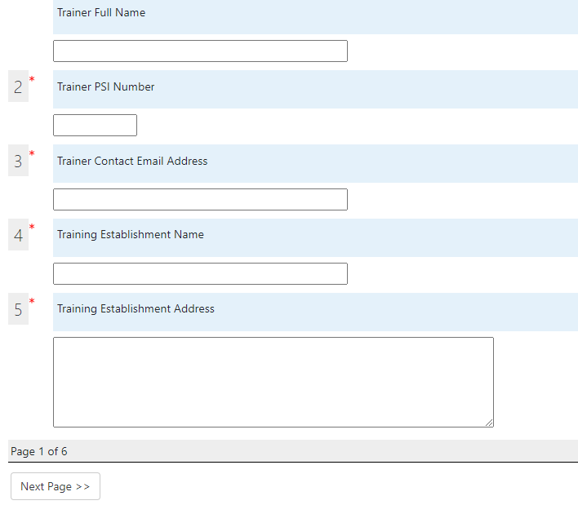

Once you have completed a page, click on the “Next Page” button at the bottom to move to the following page, or click on the “Previous Page” button to go back.

Questions with a red asterisks (*) are essential and must be completed before you can move to the following page.

PLEASE NOTE: All pages should be read carefully before moving to the following page, as you will be requested to sign that you acknowledge the contents mentioned in the form.

Declaring Connections

When declaring any connections, please make sure to provide the student’s full name, HEI and details of the connection to the student in the space provided (Example: Alex Doe, UCC, nephew).

Legal Declarations
Once you’ve read the Legal Declaration, there is option to agree or disagree. However if you select disagree for either of the options, you must contact APPEL at ops@appel.ie before progressing further thought the accreditation form.
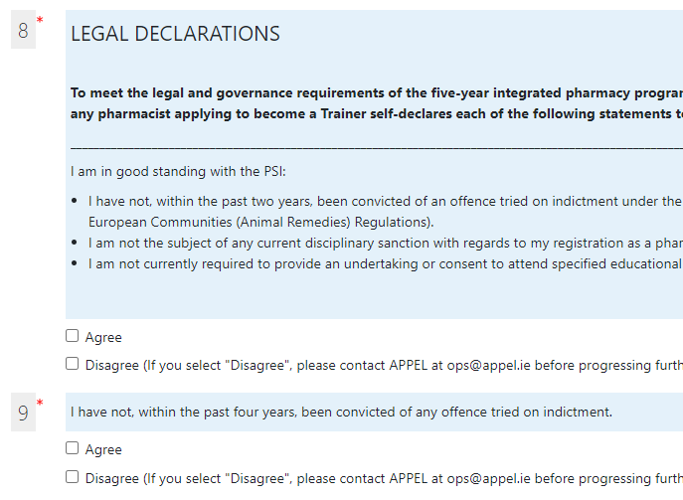
Final Declarations
Finally, to sign the form, please provide your full name and select the date on which the form was completed. Then, click the green “Submit questionnaire” button at the bottom of the page.
