How to complete your APPEL Training Establishment Accreditation Form Online

Step 1 – Access the Accreditation Form

Click here to be taken directly to the Training Establishment Accreditation Form page. Alternatively, you can access this page by searching for “Training Establishment Accreditation Form (for your premises)” in the menu on the left side of the screen of our Virtual Learning Environment.

Step 2 – Select the Form

Click on the Training Establishment Accreditation Form.

The Training Establishment Accreditation Form should be completed by a relevant person for the pharmacy, hospital pharmacy department, or organisation where the placement(s) will take place. This form must be renewed every 2 years.

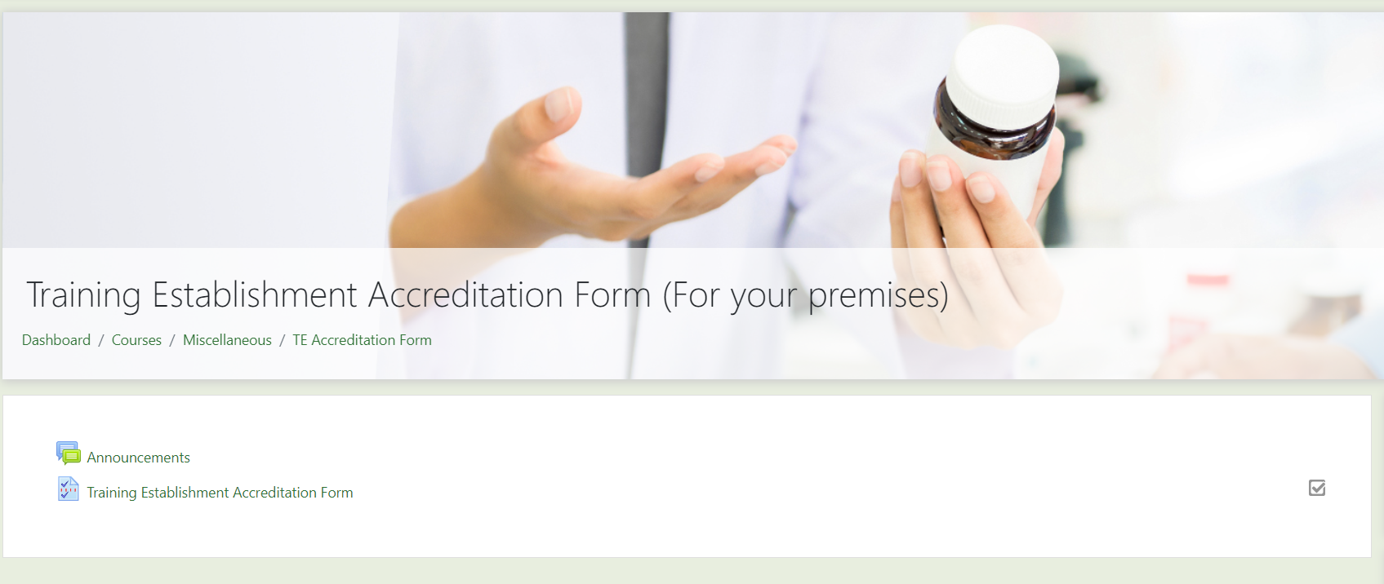

Once you have clicked the form you’d like to complete, click the green button “Answer the questions…” on the following page to enter the form.

Step 3 – Completing the Training Establishment Accreditation Form

Training Establishment Details
Provide the Training Establishment details in the spaces provided in the following format:
Training Establishment Name
Training Establishment PSI Number (if applicable)
Training Establishment Address

Example: APPEL Pharmacy
4321
Floor -1, Beaux Lane House, Mercer Street Lower, Dublin 2

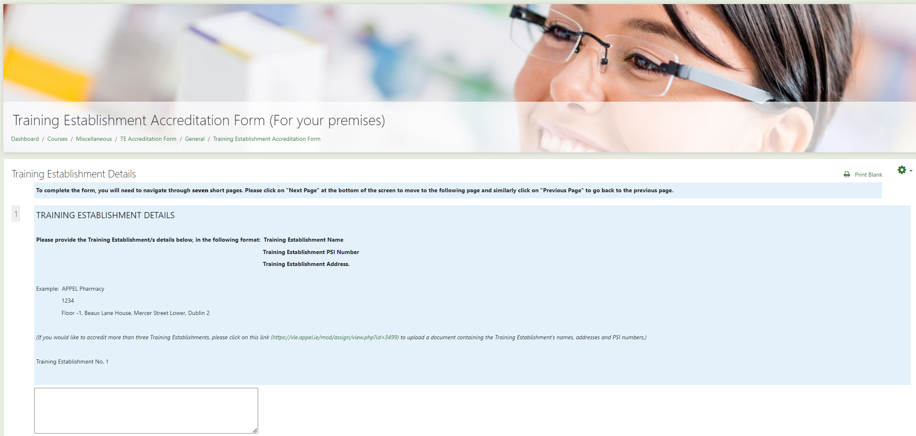

Once you have completed a page, click on the “Next Page” button at the bottom to move to the following page or click on the “Previous Page” button to go back.

Questions with a red asterisks (*) are essential and must be completed before you can move to the following page.

Declaring Connections

When declaring any connections, please make sure to provide the student’s full name, HEI and details of the connection to the student in the space provided (Example: Alex Doe, UCC, nephew).

Declarations, Joint Written Agreement and Placement Agreement
If you select false or disagree when completing any of the above sections, you must contact APPEL at ops@appel.ie before progressing further thought the accreditation form.

Final Declarations
Finally, to sign the form, please provide your full name, role and select the date on which the form was completed. Then click the green “Submit questionnaire” button.

Step 4 – For pharmacy groups or organisations with multiple sites

If you have more than three stores/sites to be accredited, please fill in the Training Establishment Accreditation form for the group/company as a whole (e.g. Shoes Pharmacies, Head Office address).
You will then need to create a document (MS Word or MS Excel) listing the stores/sites in the requested layout as mentioned above, and upload this document to this link, or by clicking on the link found in the menu on the left-hand side of the screen.
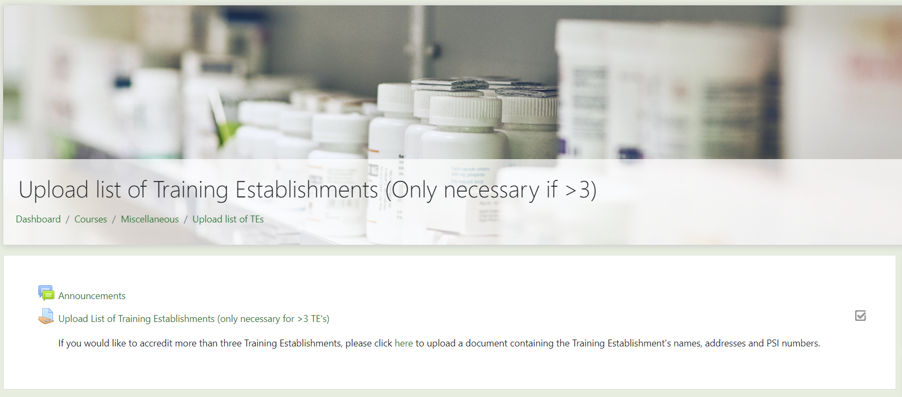
Once you have clicked on the link, click on “Add submission” in the middle of the page.
Drag and drop your document here or click on the blue downward arrow to find your document on your device by searching through your files. Once you have pasted your file, click on the green “Save changes” button.
