5th-Year Placements 2023 – Frequently Asked Questions for Students
Planning for your placement within your Schools of Pharmacy and APPEL has continued at pace throughout the past few months, with your health and well-being, together with that of your Senior Preceptors, placement teams, and patients being the primary concern. Due to the ongoing impact of COVID-19, additional requirements are being asked of every student to ensure the safe operation of these placements.
For all pharmacy experiential learning placements to proceed, students must complete a number of courses and adhere to additional requirements. We have compiled the following frequently asked questions (FAQ) to support your preparation for your experiential learning placement and explain the additional requirements you must undertake before your placement commences. Appendix 3 outlines these requirements. If you do not complete these required actions by the specified date, it may jeopardise your participation in the placement.
Please contact the APPEL office or your Practice Educator if you have any questions arising from this document.

Q. What are the dates of the 5th Year placements for 2023?
A. Students will attend their experiential learning placements from Tuesday, 3 January – Friday, 25 August 2023. Due to the Bank Holiday on Monday, 2 January, you are required to complete 22.5 hrs only during the first week of placement.

Q. What are the key placement dates for the 5th-year placements in 2023?
A. The placement dates are as follows:
- Student on placement: 3 January – 25 August 2023
- Formative assessment date: Completed by the end of week 13 (31 March 2023)
- Summative assessment date: Completed by the end of week 30 (31 July 2023)
- Focused training period (if required): 1 - 25 August
  - Please note that the placement continues until 25 August 2023, whether a focused training period is required or not.

Q. What is the student timetable for the placement period?
A. The student timetable is flexible and adaptable to accommodate the needs of the Senior Preceptor, Training Establishment and the student.
- Students must complete 30 hrs on placement between Monday and Friday (8 am – 6 pm) (excluding bank holidays), except in August 2023.
- In August of their 5th Year placement, students will be allowed to be on placement at the following times:
  - No more than one late night/evening per week – no later than 9 pm
  - No more than two Saturdays during August
- You must be provided with at least one half day each week between Monday and Friday comprising no less than 4hrs to allow you to complete your online academic modules.
- The placement timetable should be agreed upon between you and your Senior Preceptor:
  - Ideally, you would be given the same timetable each week; however, this may not always be possible.
  - You must be given adequate notice of your timetabled placement hours.
  - Your placement hours must occur over one continuous period on any given day.
- You must be provided with appropriate breaks in accordance with legislation.
Due to the flexibility of the timetable, it is important to be aware that placement hours may be adjusted to suit your needs and the needs of the Training Establishment. If you are concerned about your placement hours, please contact your Practice Educator.

Q. Do I need to complete any additional documentation or pre-placement preparation in consideration of the impact of COVID-19 on the placement?
A. Yes. As required by your School of Pharmacy and the HSE in their "Guidance on Clinical Placements in HSE Facilities and HSE Funded Facilities", you are obligated to complete and confirm a number of requirements before your placement. In addition to completing a Student Placement Agreement on the VLE before each placement (see sample agreement at Appendix 1), you must complete several courses on Infection Prevention and Control. The additional courses and reading include:
- All students must complete the following online Infection Prevention and Control courses before beginning their placement. These courses are required to be completed by your HEI and the HSE. The courses that you must complete on www.hseland.ie are as follows:

- AMRIC Introduction to Infection Prevention and Control
- AMRIC Basics of Infection Prevention and Control
- AMRIC Standard and Transmission Based Precautions
- AMRIC Hand Hygiene
- Putting on and Taking off PPE in Acute Healthcare Settings
- Putting on and Taking off PPE in Community Healthcare Settings
Courses 2 – 6 will generate a certificate once completed. These certificates must be uploaded to the VLE as described in Appendix 2. Course 1 will not create a certificate; you will need to take a screenshot once you have watched the video and upload this screenshot in the same manner.

NB - These courses must be completed anew in advance of your 5th Year placement. Course certificates dating from your 4th Year placement will not be accepted.

- The following resources are available on the HPSC website and must be reviewed by students before commencing placement.
- Review of videos on correct donning and doffing of PPE on the HPSC website https://www.hpsc.ie/a-z/respiratory/coronavirus/novelcoronavirus/videoresources/acutehealthsettingcovid-19videoresources/
- Review of the Infection Prevention and Control (IPC) Guidance, including IPC COVID-19 Guidance and educational videos on https://www.hpsc.ie/a-z/respiratory/coronavirus/novelcoronavirus/guidance/infectionpreventionandcontrolguidance/videoresourcesforipc/

- Additionally, students must read and understand the following documents and consult the following web pages:
- Guidance to minimise the risk of transmission of COVID-19 infection in pharmacies https://www.hpsc.ie/a- z/respiratory/coronavirus/novelcoronavirus/guidance/pharmacy guidance/
- The information provided by your University on COVID-19
      - https://www.ucc.ie/en/studenthealth/flu/
      - https://www.rcsi.com/dublin/coronavirus, or
    - https://www.tcd.ie/about/coronavirus/

A guide has been created to help you complete the required courses and other steps. This guide is available in Appendix 2.
The dates by which these requirements should be completed are laid out below in Appendix 3. This appendix will also act as a helpful checklist to allow you to ensure all pre-placement tasks are carried out.

Q. What if I become ill due to COVID-19 or other illnesses during placement?
A. Students must follow the public health advice in place at the time.
If you are ill due to COVID-19 or other illnesses, please follow the public health advice in place at the time. Please contact your GP or Student Health Services (info below) if you require medical advice or assistance. You must contact your Preceptor and Practice Educator if you are absent from your placement.

UCC Student Health
Telephone: 021-4902311
Address: Student Health Department, Ardpatrick, College Road, Cork
Website: www.ucc.ie/en/studenthealth

RCSI Student Health
Telephone: 01-4022300
Address: Mercer's Medical Centre, Stephen Street Lower, Dublin 2
Website: www.mercersmedicalcentre.com

TCD Student Health
Telephone: 01-8961591 or 01-8961556
Address: College Health Centre, House 47, Trinity College, Dublin 2
Website: www.tcd.ie/collegehealth

Q. What supports are available to me at this time?
- Your Practice Educator(s), Heads of School and the APPEL team are available to offer you support and assistance as required. Please note that all academic staff across all three Schools of Pharmacy will be contactable via email. Your Schools of Pharmacy / Higher Education Institution will remain in contact with you throughout this time.

Appendix 1 - APPEL Student Placement Agreement

*To be completed on the APPEL VLE*
Student Name (BLOCK CAPITALS):
School of Pharmacy (tick one): | UCC RCSI TCD
Your University Email Address:

I have agreed to undertake unpaid/paid student placements organised by the Affiliation for Pharmacy Practice Experiential Learning (APPEL) during the integrated pharmacy programme. I agree to the following terms and conditions of this placement, as set out by APPEL:
- I understand that I am a student of my Higher Education Institution (HEI) while on placement and that I must abide by and remain subject to the Schools of Pharmacy Joint Code of Conduct and all policies and procedures, including Disciplinary and Fitness to Practice Policies of my HEI/University while on placement.
- I understand that I cannot undertake any of my APPEL placements in a Training Establishment which is owned or managed by a connected relative of mine. I also understand that a connected relative of mine cannot be my Trainer* for my APPEL placements. I agree to alert APPEL to any connections I have with the Training Establishment or Trainer, which only become apparent when I am on placement.
- I confirm that I will undertake the set academic activities while I am on placement.
- I undertake to read all elements of the APPEL handbook relevant to my upcoming placement. In particular, I will ensure that I am aware of my responsibilities as a pharmacy student and aware of the set placement timetable. If I have any queries in relation to the content of the relevant handbook, I will contact an APPEL Practice Educator.
- I will ensure that I am supervised when carrying out any activities which impact patient safety. I am aware that patient safety is my utmost priority on placement and that I must immediately report any incident that may potentially affect patient safety to the Training Establishment staff.
- I understand that I have a Trainer* for the duration of my placement who will supervise me and to whom I am accountable. I accept that I shall be under the supervision of the Training Establishment staff for the duration of my placement.
- I am aware that I have support available to me from my HEI in the form of APPEL Practice Educator(s), whom I can contact by telephone or email.
- I am also aware that supports are available to me within my HEI while I am on placement, which includes medical and counselling services if a critical incident occurs while I am on my placement. I will promptly inform an APPEL Practice Educator if a critical incident occurs during my placement (examples of critical incidents include, but are not limited to, death or serious illness of a member of staff or patient, fire, hold-up, burglary, needle stick injury, injury while on placement).
- I confirm that I have disclosed any matters, which could affect my placement (including, without limitation, health issues). I acknowledge it is necessary for the disclosure (and receipt) by APPEL to (and from) my Training Establishment and HEI of personal data where necessary for administering and/or managing my placement (and which may include feedback on my student placement). In the event my contact details change, I shall notify APPEL without delay.
- I agree to promptly inform both my Training Establishment and Practice Educator if I am unable to attend my placement according to the set placement timetable for any reason.
- I will engage fully with the placement programme, including but not limited to; participating in an induction, reading and complying with the Training Establishment’s standard operating procedures (SOPs) and policies, and following any other rules and guidelines the Training Establishment may have.
- I will act in a safe, responsible and professional manner at all times and will not endanger my own safety or that of any other person. I understand that any fitness to practice or disciplinary matters arising from my placement may be dealt with in accordance with my HEI’s policies and procedures.
- I understand the importance of confidentiality with regard to patient information and commercial business information, and I shall keep any of this information, which I come across during my placement confidential.
- I will promptly contact a Practice Educator at my School of Pharmacy if:
    - Any issues arise during my placement (including any issues in relation to my health or safety or otherwise).
    - I believe that my placement is not being provided in line with APPEL’s standards.
    - I have concerns that I am not being provided with an appropriately structured and documented scheme of training that provides and exposes me to sufficient practice opportunities at an appropriate level.
    - I believe that I have not been provided with a suitable training environment that is appropriately safe, hygienic and protects my safety, health and welfare.
- I agree that my HEI shall not be held responsible by me or my representatives for any acts or omissions of the Training Establishment or its staff where I undertake my placement.
- I undertake to have a Training Plan completed and in place by the dates confirmed to me by my School of Pharmacy, APPEL and Practice Educator.

Please note that students are not authorised to amend or alter this document from the original version provided by APPEL in any way without the prior written consent of APPEL. APPEL is not obligated to accept amended placement agreements.

* ‘Trainer’ is an umbrella term used to describe supervisor, preceptor and senior preceptor pharmacists:
- Supervisor Trainer accredited by APPEL to oversee placements in 2nd year
- Preceptor Trainer accredited by APPEL to oversee placements in 4th year
- Senior preceptor Trainer accredited by APPEL to oversee placements in 5th year

COVID-19 Supplemental Student Undertaking/Declaration Undertaking Experiential Learning Placements - Infection Prevention and Control (IPC)

*This form will be signed /completed on the APPEL VLE*
In advance of the experiential learning placement as part of my studies at the University/College listed above ("University"), I acknowledge I have a personal responsibility to protect myself, patients and the general public from the potential of COVID-19 virus transmission, and to comply with Public Health Advice. Accordingly, I will ensure:

- I am aware of and have familiarised myself with COVID-19 symptoms. Please see: https://www2.hse.ie/coronavirus/
- I will not present myself to my experiential learning placement (or to the University) if I have any symptoms of COVID-19, acute infection such as symptoms of viral respiratory tract infection or gastroenteritis.
- I will not be present in clinical areas without a specific purpose related to my educational requirements, and I will limit my time in the clinical area to the minimum time necessary for learning.
- That when I am engaged in self-directed and unsupervised learning in clinical areas, I will not form groups of more than 2 or 3 people. When I am engaged in self-directed learning, I will move away from the clinical area for any extended group discussion of my learning.
- In the event that I develop COVID-19 or other communicable infectious diseases (for a list, see List of Notifiable Diseases), I will immediately notify my Trainer and the Practice Educator in my School so the School can communicate with the relevant HSE service (where applicable)/Training Establishment, in case it has implications for patients and staff.
- I will keep myself up-to-date and comply with current Public Health Advice regarding COVID-19.
- In advance of commencing my experiential learning placement, I will comply with all Infection Prevention and Control training required by my School and the HSE.
- I will ensure that I abide by, and comply with, the rule of 'bare below the elbows/bare above the wrist' while on placement, where applicable.
- I acknowledge I must be assessed and certified as competent in the performance of hand hygiene in advance of my placement and will undertake a competence review at least once in each academic year.
- I will comply with Infection Prevention and Control directions given by the HSE, my Trainer and other Clinical staff at all times when I am in clinical areas, and any other measures the HSE or my Trainer has in place to prevent the emergence of COVID-19 while I am on placement.
- I will cooperate with requirements for the management of outbreaks or other incidents of infection, including providing samples for testing where required.
- That if I have chosen not to be vaccinated against key respiratory viruses (SARS-CoV-2 and Influenza) in accordance with current public health guidance, I will, to the greatest degree practical, limit contact with patients in high-risk areas in particular haematology and oncology in-patient areas, haemodialysis services, intensive care units including neonatal intensive care units
- That if I have chosen not to be vaccinated against key respiratory viruses (SARS-CoV-2 and Influenza) in accordance with current public health guidance, I will not engage in any unsupervised learning activity that places high-risk patients /clients at risk of infection related to my vaccination choice
- I have completed the required infection prevention and control training in advance of my experiential learning placement as directed by my School of Pharmacy and APPEL, including Standard and Transmission-based Precautions, and have uploaded the certificates of said courses as required. I understand this training must be completed annually, and certificates must pertain to the current year.
- I confirm that I will complete the relevant PPE training, including training on www.hseland.ie and videos on www.hpsc.ie, to ensure the correct donning and doffing of PPE as directed by the School of Pharmacy and APPEL.
I acknowledge that my placement is subject to Public Health Advice, which may be in place from time to time, and that public health advice may result in changes to arrangements during the course of my placement.

Data Protection
Any information disclosed to the University pursuant to this declaration will be treated with the highest standards of security and confidentiality and processed in accordance with the University's Data Protection Policy. The University is collecting this personal data in light of the COVID-19 pandemic and to implement the requirements of the HSE in relation to the undertaking of experiential learning placements. The legal basis for processing this data is based on protecting vital interests and for the reasons of public interest in the area of public health.
Signature |  | Name |  | Date
*This form will be signed /completed on the APPEL VLE*

Appendix 2: Guide to completing pre 5th Year placement requirements on the APPEL Virtual Learning Environment (VLE)
As required by your School of Pharmacy and the HSE in their “Guidance on Clinical Placements in HSE Facilities and HSE Funded Facilities”, you are obligated to complete and confirm a number of requirements prior to the commencement of your placement. In addition to completing a Student Placement Agreement before each placement, you must complete a number of courses pertaining to Infection Prevention and Control. For your convenience, the Student Placement Agreement and the course certificates can be completed and uploaded to the APPEL VLE.
Remember that the courses must be completed in advance of your 5th Year placement. Old certificates dating from your 2nd or 4th Year placements will not be accepted.
The courses that you must complete on www.hseland.ie are as follows:
- AMRIC Introduction to Infection Prevention and Control
- AMRIC Basics of Infection Prevention and Control
- AMRIC Standard and Transmission Based Precautions
- AMRIC Hand Hygiene
- Putting on and Taking off PPE in Acute Healthcare Settings
- Putting on and Taking off PPE in Community Healthcare Settings
Courses 2 – 6 will generate a certificate once you complete them; these certificates must be uploaded to the VLE as described below. Course 1 will not generate a certificate; you will need to take a screenshot once you have watched the video and upload this screenshot in the same manner.
Instructions
- Access the VLE via the following link - https://vle.appel.ie/login/index.php and log in, as usual, using your EduGate login details.
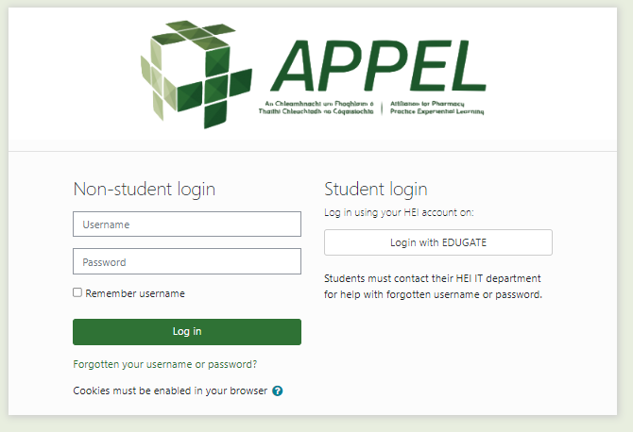
- Navigate to the course - 2023-Year 2 APPEL Student Placement Agreement via the following link (https://vle.appel.ie/course/view.php?id=188 )
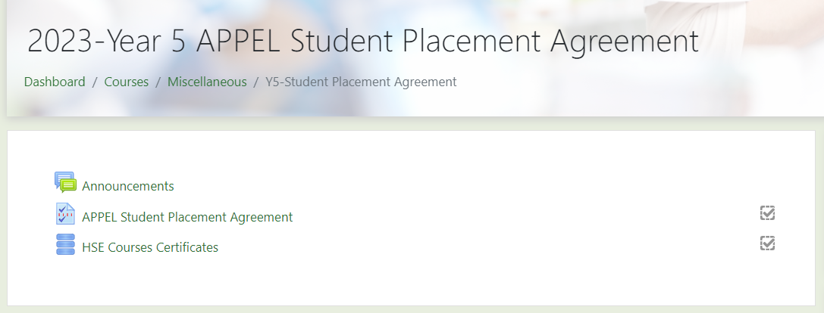
- Open the link to the Student Placement Agreement, enter your details on the first page and read through the sections on pages 2, 3 and 4.
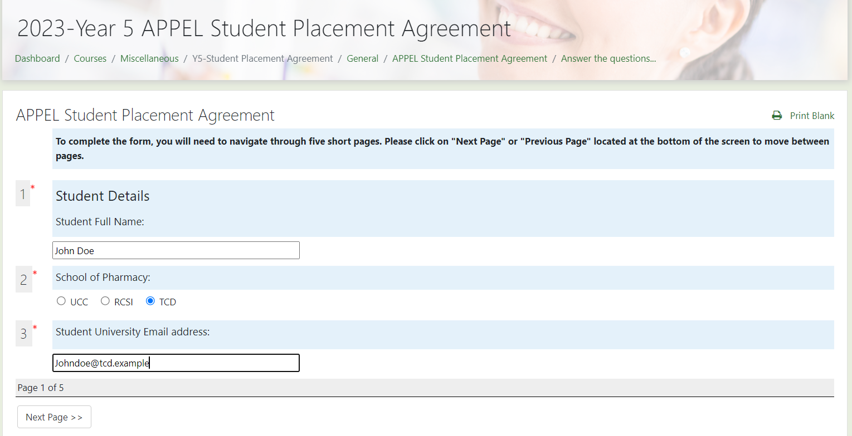
- On page 5, sign and date the form. You must read this document carefully, and if you have any questions, please contact APPEL or your Practice Educator.
- To upload your HSE course certificates, access the second activity in the course “HSE Courses Certificate” , and the following page will be displayed:
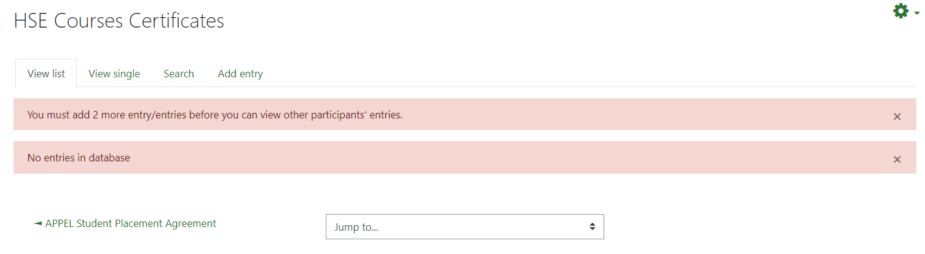
- To add your certificates, click on the 'Add Entry' button.

- Once you have entered your name, HEI and email address, you can begin uploading each certificate or screenshot in the specified area. Click on the blue arrow in each section to open the menu and select the correct certificate. Certificates must be uploaded during the same login session, so please complete all courses and have the certificates and screenshot ready to upload at this point.
NB: There is a specific area for each certificate – please ensure that you upload the correct certificate into each area.
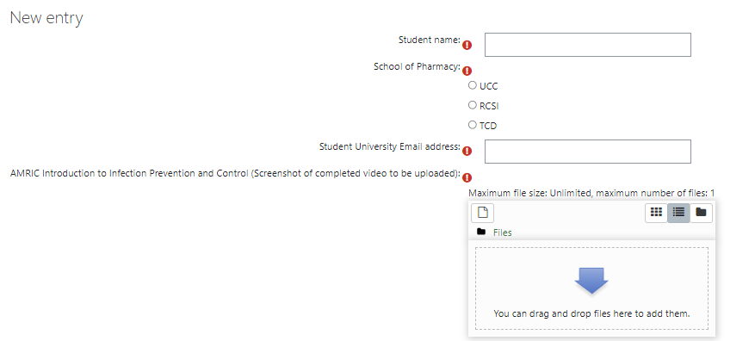
- Once you have uploaded all 6 documents, at the bottom of the page, click on the green 'Save and View' button to ensure everything is correct.

- There is no need to take any further action at this point. Once you have uploaded, the APPEL team can view your submissions. The APPEL Ops team will approve the submission for each student and contact you if there are any issues.
Please ensure you have uploaded the correct certificates/screenshot to the right area and completed the Student Placement Agreement in full. Failure to do so may cause delays in approving your attendance on placement.

Appendix 3- Actions to be completed
Actions to be completed | Deadline
- Complete the updated Student Placement Agreement, incorporating a COVID-19 Supplemental Student Undertaking/Declaration and undertakings pertaining to Infection Prevention and Control measures on the APPEL VLE | 18/11/22
- Complete the HSELand e-learning courses and upload the certificates to the APPEL VLE  - AMRIC Introduction to Infection Prevention and Control  - AMRIC Basics of Infection Prevention and Control  - AMRIC Standard and Transmission Based Precautions  - AMRIC Hand Hygiene  - Putting on and Taking off PPE in Acute Healthcare Settings  - Putting on and Taking off PPE in Community Healthcare Settings | 18/11/22
- Review the resources available on the HPSC website on donning and doffing of PPE and IPC guidance | 18/11/22
- Read and understand the Guidance to minimise the risk of transmission of COVID-19 infection in pharmacies and the information provided by your University on COVID-19 | 18/11/22

